Provisional marking key

1 a $\frac{a-c}{abc}$
$\frac{-3-\left(-1\right)}{ \left(-3\right)\left(2\right)\left(-1\right)}$ 1 mk see any 1 correct substitution
$\frac{-3+1}{6}$ 1 mk see any 1 correct simplification: +1 or +6
$\frac{-2}{6}$
$-\frac{1}{3}$ 1 mk for correct answer

1b $V=$ $\frac{M}{D}$ 1 mk for the idea of density equivalent to relative density
$\frac{273}{2.1}$ 1 mk for any 1 correct substitution
130 1 mk

2a ${\left(\frac{x^{0}}{y^{-1}}\right)}^{2}$
$\left(\frac{x^{0}}{y^{-2}}\right)$ 1 mk for raising both variables to power 2 or 1 for xº
$\frac{1}{\frac{1}{y^{2}}}$
$1 ÷ \frac{1}{y^{2}}$
$1× \frac{y^{2}}{1}$ 1 mk for using law 2 of indices or using inversion idea
$y^{2}$ 1 mk
2b $\frac{y}{y+12} = \frac{1}{4}$ 1 mk for substituting into the probability formula
$4y =y+12$ 1 mk for cross-multiplication
$4y -y =12$ 1 mk for trying to isolate y – see y to one side or dividing by y
$3y =12$
$\frac{3y}{3} = \frac{12}{3}$
$y =4$ Green ball $=$ 4 1 mk for the correct value
3a.
$angle SQT =angle QSR$ (alternate or z angles) 1 mk
$angle QRS={65}^{0}$ (base angles) 1 mk
$angle QRS =angle PQT$ = 65º (Corresponding angles) 1mk
3b $8 people =6 hours$
$12 people =less$ 1 mk
$\frac{8×6}{12}$ 1 mk
$\frac{48}{12}$
$4 hours$ 1 mk
4. $7≤2x +1 <0$
$7≤2x +1$ $2x +1 <0$
$7 -1 ≤2x$ $2x < -1$
$6 ≤2x$ $\frac{2x}{2} < \frac{-1}{2}$
$\frac{6}{2 } ≤ \frac{2x}{2}$ 1 mk - see dividing by 2 $x < -\frac{1}{2}$ 1 mk – see $\frac{1}{2}$, even if the sign is +
$3$ $≤x$
$-\frac{1}{2}<X ≤3$ 1 mk for either side correct
1 mk when everything is correct
-1 0 1 2 3 4
5a. ${13201}_{4} to base 10$
$1× 4^{4} +3×4^{3} +2×4^{2} +0 ×4^{1} +1×4^{0}$ 1 mk for any one correct power of 4
$1×256 +3×64 +2×16 +0×4 +1×1$ 1 mk for any one correct value of power 4 – see 256, 64, 16 or 4
$256 +192 +32 +0 +1$
${ 481}_{10}$ 1 mk

5b. $-y -3x =2$
$-y =3x +2$
$\frac{-y}{-1} = \frac{3x}{-1} + \frac{2}{-1}$ 1 mk for the attempt to make y subject – see dividing by +1 or – 1
$y = -3x -2$ 1 mk – see +y
Gradient $=-3$ 1 mk for correct answer

6. $tc -nr -cr +nt$
$tc +nt -nr -cr$ M1
$\left(tc +nt\right)\left(-nr-cr\right)$ 1 mk for rearranging
$t\left(c +n\right) -r\left(n +c\right)$ 1 mk for removing common factor t or -r
1 mk for one correct value within a pair of bracket
$\left(t-r\right)\left(n+c\right)$ 1 mk
7. Let the exterior angle be $=x$, interior angle be $=4x$
$4x +x ={180}^{0}$ 1 mk for idea of angles on a straight line even if the LHS is
wrong
$5x = {180}^{0}$
$\frac{5x}{5} =\frac{{180}^{0}}{5}$ 1 mk for trying to isolate x
$x ={36}^{0}$
$exterior angle = \frac{{360}^{0}}{n}$
$=\frac{{360}^{0}}{{36}^{0}}$ 1 mk for substituting into formula to find no. of sides
$=10, Deacagone$ 1 mk for correct name

8. $x-t =\frac{yx}{r}$
$r×x-t×r =\frac{yx }{r}×r$ 1 mk for attempting to remove r from being a denominator –
see r multiplying with any two terms
$rx-rt=yx$
$rx-yx =rt$ 1 mk – see terms with x to one side of equal sign
$\frac{x\left(r-y\right)}{\left(r-y\right)} = \frac{rt}{\left(r-y\right)}$ 1 mk – see dividing with by her pair of bracket
$x = \frac{rt}{r-y}$ 1 mk for correct answer

9. -2n + x = n^{th} term 1 mk for finding d = - 2 or making 2 the coefficient of n
-2 x 1 + x = 11 1 mk for equating with any 1 age with its position
x = 11 + 2 = 13
13 – 2n = n^{th} term 1 mk
10.
No. | log
$$5.25$$ | 0.7202
$$1.14$$  $$2.1$$ | 0.0569 M1  0.3222 + M1
 | 0.3791 0.3791 - M1
2.193 | 0.3411 M1
1 mk for the log of 5.25 1 mk for idea of adding logs when numbers are multiplying even if the logs are wrong 1 mk for correct sum of logs 1 mk for idea of subtracting logs when numbers are dividing even if the values are wrong 1 mk for attempting to find the antilog of her value even if it is wrong
Log $\frac{5.25}{1.14 ×2.1} =2.193$ 1 mk for correct answer

11. $AC=CE (Given)$
$angle BAC =angle DEC$ Alternate angles 1 mk
$angle ABC =amgle EDC$ Alternate angles 1 mk
$Triangle ABC ≡Triangle DCE$ SAA 1 mk
$∴$ BC = DC (corresponding sides of congruent triangles) 1 mk for the correct conclusion
12. $2x =1 +y$ …….. 1
$x+y =5$ ………2
$y =2x-1$ ……3 1 mk for $making y in equetion 1 subj$
$x +2x-1 =5$ 1 mk for substituting y value in (2)
$3x =5 +1$
$3x =6$
$\frac{3x}{3} =\frac{6}{3}$
$x=2$ 1 mk for correct x value
$sub 2 in eque 3 y =2x-1$
$y =2\left(2\right)-1$
$y=4-1$ 1 mk for the 4 or any number according to her x
$y =3$
$x =2, y =3$ 1 mk for correct y value
Method 2 By elimination
. 2x – y = 1 1 mk for transposing the y to LHS
x + y = 5 3x = 6 1 mk for adding to eliminate y x = 2 1 mk for correct x value 2 x 2 – 1 = y 1 mk for substituting with x with 2 3 = y 1 mk for correct y value

13. 4,800 0% tax free
$\frac{9,600 ×10}{100} =960$ 1 mk – see division by 100
9,600 + 4,800 $=$ 14,400 1 mk – see adding 0 rate value by her 10% even if it is wrong
48800 $- 14400 =34,400$ 1 mk – see subtracting her value from gross pay even if it is wrong
$\frac{34400 ×25}{100}$ $=8,600$ 1 mk – see correct 25%
$total tax =8,600+960$
$=K 9560$ 1 mk for correct answer

14. ${LB}^{2} = {BF}^{2 }+ {LF}^{2}$
${6.5}^{2} = {2.5}^{2}+x^{2}$ 1 for any 1 correct substitution into the correct Pythagoras’ theorem – see LB² alone to one side
$42.25-6.25= x^{2}$ 1 mk – see any 1 correct square
$x^{2}=36$
$x^{2}=6^{2}$ 1 mk for square rooting both sides or raising 6 to power 2
$x=6$ 1 mk for correct answer

15. 12 + 5 + 3 = 20
$\frac{12 ×360}{20} ={216}^{0}$ 1 mk for any 1 angle correct
$\frac{5×360}{20} ={90}^{0}$
$\frac{3 ×360}{20} ={54}^{0}$ 1 mk for all angles correct
1 mk for any one correct sector with correct angle
1 mk for sectors correct
1 mk when everything – see all sectors correctly labelled
[NB: When marking measure any two angles with a protractor, when they are correct award all the marks. When wrong, go back and award the other marks.]
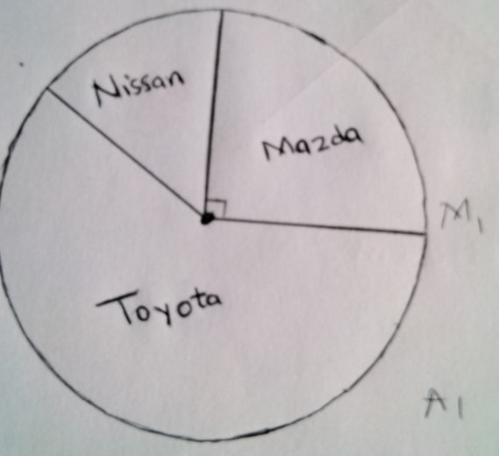

16.
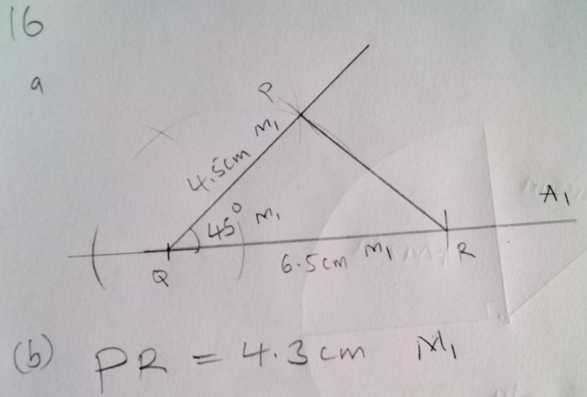
1 mk for PQ = 4.5$±$0.1 cm 1 mk for QR = 6.5$±$0.1 cm 1 mk for angle PQR = 45º$±$3º 1 mk for neatness, see thin consistent lines, see no erasing with finger, etc 1 mk for PR = 4.3$±$0.1 cm [NB: When PR is within the correct Range of 4.2 to 4.4 cm, award all the 4 marks.]

17. $\frac{x^{2} +2x}{x^{2}} =\frac{2x +4}{x-3}$
$\frac{x(x +2)}{x^{2}}=\frac{2x+4}{x-3}$ 1 mk – see factoring out x in numerator
$\frac{x+2}{x} =\frac{2x+4}{x-3}$ 1 mk – see cancelling out x
$x\left(2x+4\right)=(x+2)(x-3)$ 1 mk – see cross multiplying her values
$2x^{2}+4x=x^{2}-x-6$ 1 mk for expanding either one correctly
${ x}^{2}+5x+6=0$
$\left(x+2\right)\left(x+3\right)=0$ 1 mk – see attempting to factorise – see at least 1 bracket correct
$x+2=0 or x+3=0$
$x=-2 or x=-3$ 1 mk – see both x values correct

18. Given set A= $\left\{1,3,4\right\}$
a. Number of subset = $2^{n}$
$2^{3}$ 1 mk – see substituting 3 into formula
= 8 1 mk – see the 8 not 6
b. $\left\{1\right\} ,\left\{2\right\},$ $\left\{3\right\},$ $\left\{1,2\right\},$ $\left\{1,3\right\}, \left\{2,3\right\}, \left\{1,2,3\right\},$ { } 1 mk for three correct subsets 1 mk for any further 2 correct subsets 1 mk for all correct subsets
19 Area of PQRS = $L×B or s^{2}$
= $8 cm×8 cm$
= $64 {cm}^{2}$ 1 mk for correct area
Area of a triangle = $\frac{1}{2}( base ×height$)
= $\frac{1}{2} (8 cm ×7 cm)$ 1 mk for any 1 correct substitution into formula of area of triangle
= $\frac{1}{2}(56 {cm}^{2})$
= $28 {cm}^{2}$ 1 mk for correct area
Total areas for 4 triangles =$4 ×28{cm}^{2}$ 1 mk for multi plying 1 area by 4
= ${112cm}^{2}$
Total areas for the pyramid = $112 {cm}^{2 }+{64 cm}^{2}$ 1 mk – see the plus sign
= ${176 cm }^{2}$ 1 mk for correct answer

20. 1 mk for correct scale on either axis distance = 50km/h x 1 h = 50 km at 07:00 1 mk for finding distance of motorist X after 1 h 1 mk for time taken by motorist Y = 120 km $÷$ 80 km/h = 1h 30 min, arrive at 08:30 1 mk for one correct graph of either motorist 1 mk for time of overtaking = 07:40 $±$ 2 min

Distance (km)
120 |  |  |  | Y
100

80

60

40 | X
20

06:00 06:30 07:00 07:30 08:00 08:30 09:00 09:30 10:00 Time (h)

